# Laboratory 4

Title of the Laboratory Exercise: HTML and JSP form to implement the functional requirement (Example: Registration page)

1. Introduction and Purpose of Experiment

Students will learn to use will HTML and HTML Frames in html platform.

1. Aim and Objectives

Aim

Objectives

1. Experimental Procedure
2. Calculations/Computations/Algorithms

**register.jsp**

<%@ page contentType="text/html;charset=utf-8" %>

    <html>

    <head>

        <title>Register</title>

    </head>

    <body *style*="text-align:center; margin:auto">

        <h1>Register</h1>

        <br />

        <center>

            <form align="center" *action*="register" *method*="post">

                <table>

                    <tr>

                        <td>username</td>

                        <td><input *type*="text" *name*="username" /></td>

                    </tr>

                    <tr>

                        <td>password</td>

                        <td><input *type*="password" *name*="password" /></td>

                    </tr>

                    <tr>

                        <td>full name</td>

                        <td><input *type*="text" *name*="fullname" /></td>

                    </tr>

                    <tr>

                        <td>usn no</td>

                        <td><input *type*="text" *name*="usnno" /></td>

                    </tr>

                    <tr>

                        <td>dept</td>

                        <td>

                            <select *name*="dept">

                                <option *value*="CSE">CSE</option>

                                <option *value*="EEE">EEE</option>

                                <option *value*="ECE">ECE</option>

                                <option *value*="CIVIL">CIVIL</option>

                            </select>

                        </td>

                    </tr>

                    <tr>

                        <td>course</td>

                        <td>

                            <select *name*="course">

                                <option *value*="B.Tech">B.Tech</option>

                                <option *value*="M.Tech">M.Tech</option>

                            </select>

                        </td>

                    </tr>

                </table>

                <br />

                <input *type*="submit" *value*="register" />

            </form>

        </center>

    </body>

    </html>

**web.xml**

<web-app>

    <servlet>

        <servlet-name>index</servlet-name>

        <jsp-file>/index.jsp</jsp-file>

    </servlet>

    <servlet-mapping>

        <servlet-name>index</servlet-name>

        <url-pattern>/</url-pattern>

    </servlet-mapping>

    <servlet>

        <servlet-name>register</servlet-name>

        <jsp-file>/register.jsp</jsp-file>

    </servlet>

    <servlet-mapping>

        <servlet-name>register</servlet-name>

        <url-pattern>/register</url-pattern>

    </servlet-mapping>

</web-app>

1. Presentation of Results

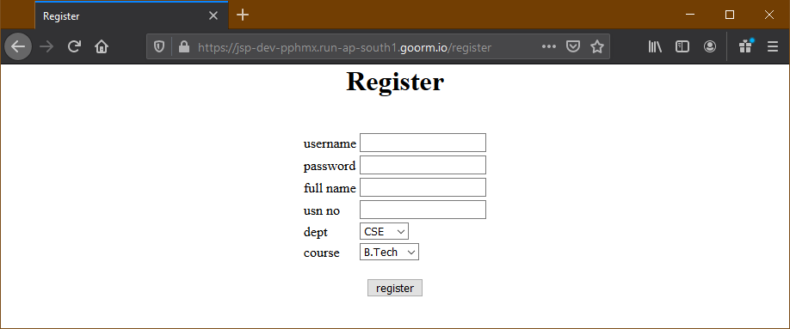

1. Analysis and Discussions

Frameset is basically a tag in HTML. It is used to create several frames in single web page and each of those frames can contain separate HTML documents. The tag is used to divide the browser window in several frames. Frames divide browser window in frames just like rows and columns in tables. If you are comfortable with the concept of creating tables in HTML then frames won't be difficult. HTML forms the basis of web development. If you see yourself as a builder of websites with a solid structure then an in-depth knowledge of HTML is indispensable.

The Hyper Text Mark-Up Language, also known as HTML is a mark-up language used to build customized websites. The HTML language is made up of tags that are used to build web pages from scratch. HTML is an essential but valuable skill. Beginners tend to neglect the importance of this language and this might be one of the biggest mistakes they commit in their formative years as developers.

HTML frames allow authors to present documents in multiple views, which may be independent windows or subwindows. Multiple views offer designers a way to keep certain information visible, while other views are scrolled or replaced. For example, within the same window, one frame might display a static banner, a second a navigation menu, and a third the main document that can be scrolled through or replaced by navigating in the second frame.

1. Conclusions

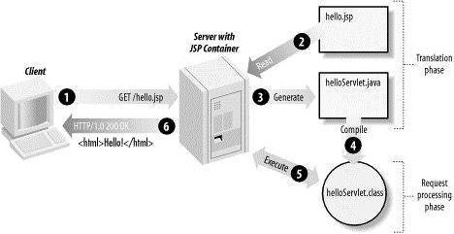

JSP page is really just another way to write a servlet without having to be a Java programming wiz. Except for the translation phase, a JSP page is handled exactly like a regular servlet.

1. Comments

There are few drawbacks with using frames, so it's never recommended to use frames in your webpages:

* Some smaller devices cannot cope with frames often because their screen is not big enough to be divided up.
* Sometimes your page will be displayed differently on different computers due to different screen resolution.
* The browser's *back* button might not work as the user hopes.
* There are still few browsers that do not support frame technology.

a. Limitations of Experiments

The JSP developer needs to know Java. Again, one developer s asset is another s liability. Whereas Java is certainly more full-featured and flexible than other page scripting languages, no one can argue that the learning curve for Java is far steeper than other scripting languages. If you already know Java this is not an issue.

JSP pages must be compiled on the server when first accessed. This initial compilation produces a noticeable delay when accessing the JSP page for the first time.

The developer may compile JSP pages and place them on the server in compiled form (as one or more class files) to speed up the initial page access. The JSP developer may need to bring down the server to make the changed classes corresponding to the changed JSP page.

b. Limitations of Results

None

c. Learning happened

We learnt how to make the Registration Page in JSP, along with HTML forms.

d. Recommendations

None

|  |  |  |
| --- | --- | --- |
| **Component** | **Max Marks** | **Marks Obtained** |
| **Viva** | **6** |  |
| **Results** | **7** |  |
| **Documentation** | **7** |  |
| **Total** | **20** |  |